Oxfordshire’s model of restorative practice

Restorative Practice is a core approach for Oxfordshire Children and Families and partner agencies. Different levels of training are available and it’s important that everyone can access training at the appropriate level for their role. The restorative approach embeds a commitment to work with children and families rather than doing things to or for them and encourages reflective practice.

Restorative principles and values

Restorative practice is rooted in principles and values. These principles and values underpin restorative processes. They also form the basis of what is sometimes called a restorative mind-set. Embedding restorative practice depends on these principles and values being fully understood, modelled by restorative practitioners and nurtured within the people they work with.

The Restorative Justice Council, the independent membership body which champions high quality restorative practice in the UK, identifies six principles that form the underpinning ethical framework for all forms of restorative practice.
RJC Principles of Restorative Practice

1. Restoration – the primary aim of restorative practice is to address participants’ needs and not cause further harm. The focus of any process must be on promoting restorative practice that is helpful, explores relationships and builds resilience.

2. Voluntarism – participation in restorative practice is voluntary and based on open, informed and ongoing choice and consent. Everyone has the right to withdraw at any point.

3. Impartiality – restorative practitioners must remain impartial and ensure their restorative practice is respectful, non-discriminatory and unbiased towards all participants. Practitioners must be able to recognise potential conflicts of interest which could affect their impartiality.

4. Safety – processes and practice aim to ensure the safety of all participants and create a safe space for the expression of feelings and views which must result in no further harm being caused.

5. Accessibility – restorative practice must be respectful and inclusive of any diversity needs such as mental health conditions, disability, cultural, religious, race, gender or sexual identity.

6. Empowerment – restorative practice must support individuals to feel more confident in making their own informed choices to find solutions and ways forward which best meet their needs

Related values central to the approach include:

Accountability Collaboration Confidentiality

Honesty Listening

Non-judgement Openness Self-determination

The five restorative themes and the restorative framework

Oxfordshire’s framework for restorative practice has been adapted from the Transforming Conflict model developed by Dr Belinda Hopkins. You can find out more about this model at www.transformingconflict.org. This model is based on 5 core beliefs:

Theme 1 – Unique perspectives
Linked question: What happened?
Every person has a unique perspective on any situation. We create time and space for everyone to share their personal stories and narratives through respectful and non-judgemental listening, recognising that good-quality attention is a precious resource.

Theme 2 – Thoughts and Feelings
Linked questions: What were you thinking? And how were you feeling?
Our interpretation of events (our thinking) impacts on our emotional response and this in turn influences what we say or do. When we reflect on what we are thinking and feeling, we become more self-aware and develop self-empathy. When we are able to share our thoughts and feelings with others, this can help develop their sense of empathy towards us.

Theme 3 – Harm and Affect
Linked questions: Who’s been affected? How?
We are all connected, and an important part of growing up is to recognise that our actions have consequences for others. For both the person harmed and the person who caused harm it can be an opportunity to reflect on and process the experience. If we hurt someone, we can learn how others are affected, and by exploring how far the ripples of harm can spread, the restorative approach encourages responsibility and accountability and can be a significant step towards building empathy.

Theme 4 – Underlying Needs
Linked questions: What do you need to feel better? Sounds like you need……?
Whether someone has caused harm or been harmed they are likely to have similar needs. This stage of the restorative process is about identifying underlying needs – rather than focussing on what someone demands or wants from the other person. If underlying needs can be identified this will help people understand what they need to move forward which will help to repair relationships.

Theme 5 – Ownership of Solutions
Linked questions: What needs to happen to move forwards? (What needs to happen to put things right?)
The people who are affected by a situation or event are best placed to identify what needs to happen so that everyone can move on and so that harm can be repaired. In this stage of the process the ownership of decision making and solutions remains with the people affected and this empowers all parties to be in control of the restorative process which is about doing things “with” people rather than “to” of “for” them.

This 5-staged-structure is reflected in all restorative processes e.g., restorative conversations with one person, restorative meetings, restorative circles and larger restorative processes.

The Social Discipline Window

The Social Discipline, or “4 choices window”, shown below, was developed by Wachtel and McCold in 2001 to define a restorative approach in educational, residential or indeed any institutional or organisational setting.

The Wachtel and McCold Social Discipline Window

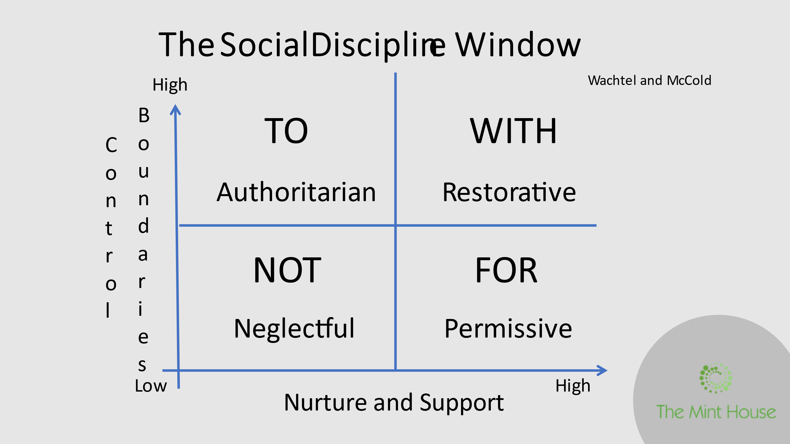

Within Children’s Social Care, the social discipline window has been widely interpreted to suggest that effective work with families sits entirely in the WITH window and is characterised by taking an approach that is “high support, high challenge”. This is used to explain and promote working collaboratively, alongside and “with” families.

Within Oxfordshire, reflection and practice experience points to limitations with this model in describing what restorative practice looks like or supporting practitioners to understand how to practice restoratively.

- The social discipline window places restorative practice in the ‘with’ window (the top right-hand quadrant) combining ‘high support and high control’, sometimes described as “high support, high challenge.” This can lead to the practitioner being unsure if being supportive, or directive or at times allowing is permissible.

- Rather than being restorative, an approach combining high boundaries and control with high nurture and support might translate into a smothering or over-involved approach, for example, a “helicopter” parent or worker or micro-manager.

- The model as a whole also fails to reflect the change and adjustments needed when working effectively and the journey through family work that leads from high support, high boundaries/challenge through empowerment to allowing and letting go.
The Alternative Social Discipline Window or “Nine Choices Window” developed by Pete Wallis and Jo Brown (shown below) aims to provide a more accurate representation of what it means to work restoratively and to support practitioners to reflect, analyse and plan how to practice restoratively.

The Alternative Social Discipline Window or “Nine Choices Window”

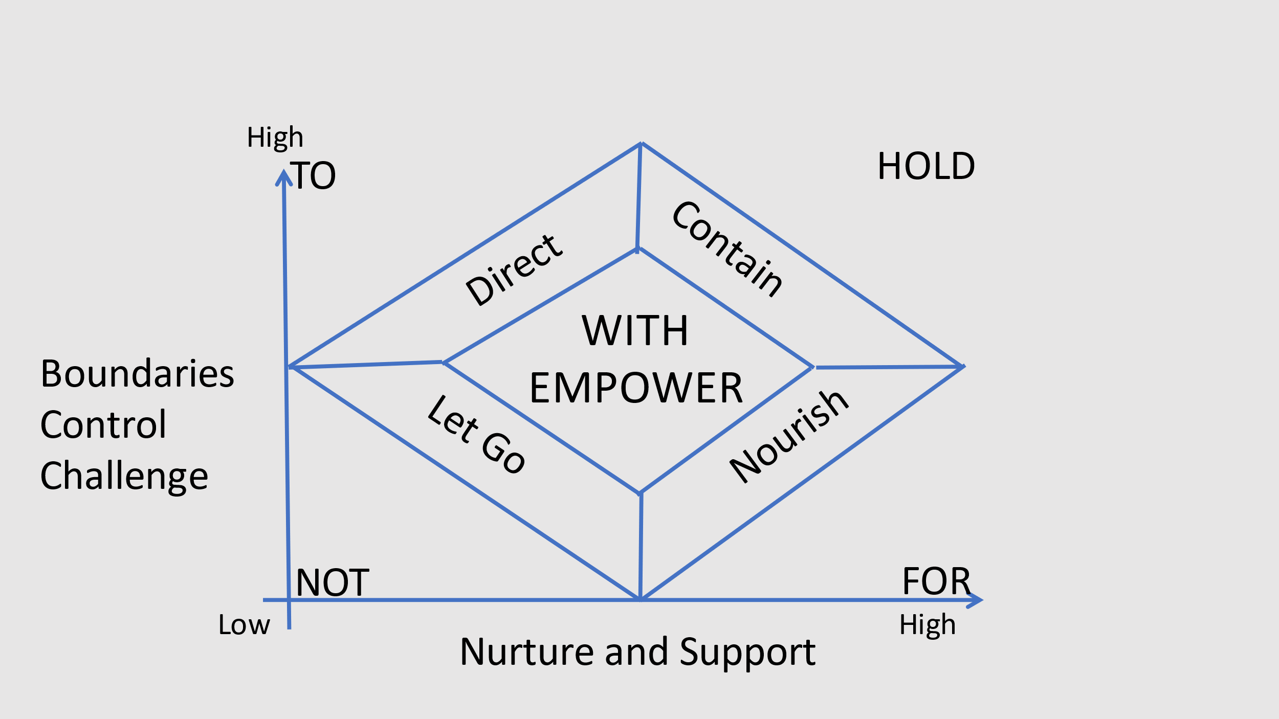

The model sees working “with” and empowering as sitting in the middle of the grid, with the restorative practitioner having to move away from the centre of the grid at times into areas of the different windows.

- When a restorative practitioner starts working with a case, they are likely to start in the “contain” area of the model where there are higher levels of boundaries or challenge and support. This could also apply to a school, children’s home or foster home when a child is new to the environment. A restorative practitioner may have to provide a “containing” approach at other times when appropriate. For example, in a school or child-care setting, sometimes a child needs a high-level of containment and support in order to feel safe and to help de-escalate a challenging situation. This can also apply to families needing a high level of support and boundaries or challenge, particularly when managing risk.

- At times the practitioner or the environment will need to be more directive or nourishing and supportive, depending on the needs of the children or families they are working with.

- The goal of the restorative practitioner is to work collaboratively and with the child or family, but only until they are ready to manage things for themselves without our support. An empowering approach is about building skills for

self-management so that we can “let go” when children/people no longer need our support.

- Restorative practice is seen as a journey, and the model can be used to reflect on your practice and approach and to enable people to plan how to manage a case restoratively.

- The model can also be used to reflect on when our practice is “falling off the corners”. Although the central areas of all windows are appropriate at different times, practice at the corners of the model is not likely to be helpful. High levels of demand and stress can impact on workers and managers and cause them to stray into the corners despite their best intentions.

- The restorative journey is mirrored in running a restorative process or meeting. At the beginning, the facilitator provides high levels of support and boundaries, providing clarity about the purpose of the meeting and guidelines are agreed with the participants about how the meeting will run. As the meeting progresses, the facilitator aims to make sure that the meeting belongs to the participants and in the best meetings the facilitator is able to sit back and allow the people to communicate with each other and find their own solutions, stepping in only when necessary to maintain the focus and support a positive outcome.

Using the model as a tool for reflecting on an incident or case or planning how to move forwards

The choices grid can be used to consider “how restorative?” an approach is. This can be related to:

- Team and organisation function
- How people characteristically interact with others
- Reflecting on your management style and approach
- Reflecting on how an incident has been/or should have been dealt with
- Reflecting on casework to support planning with how to practice restoratively and identify what’s getting in the way of effective working both in professional meetings and as part of supervision.

Key points to remember are:

- Different areas of the window are appropriate at different times
- Working restoratively involves empowering people to find their own solutions
- Identifying when our practice is “falling of” the corners can help us reflect and identify how practice can be more restorative.

