What is my home like for me?
Working together to help children, young people and families to thrive

This is a reflective tool to help with recording the state of the home. It is intended to support children to share their thoughts/feelings.

- The picture helps children explore their thoughts and feelings around the place they live
- Workers may find it helps to use an actual picture of the child/family’s home
- The questions included are examples and should be edited before use and to highlight any concerns

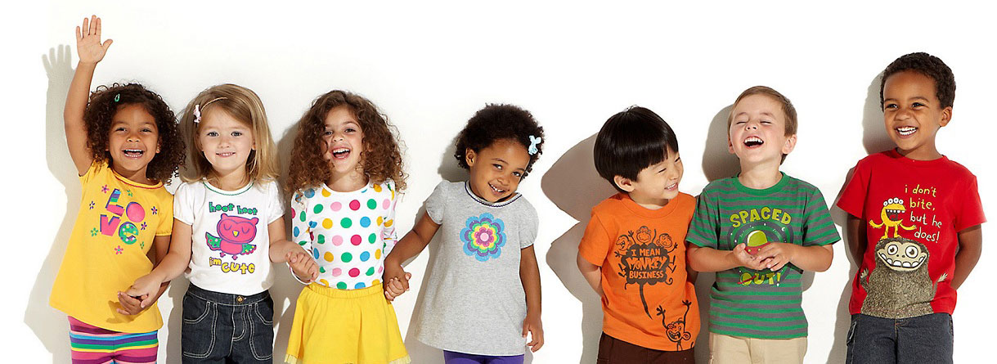

What is my home like for me?
What is the toilet like?
What are the stairs like?
What is my space like?
What makes me happy/sad here?
Is there enough food to eat?
Where is my toothbrush?
What is the bathroom like?
Who lives in the house?
Where do I sit to do school work?
What is upstairs/ in the attic/loft/ storage?
What is the bath or shower like?
Who is staying or visiting?
What things don’t we see?
What is on the doormat?
What do I see when I get home?
How do we wash up and do laundry?
What is in the outside spaces
How does my home make me feel?
What is in the cupboards?
What food do we eat?
Where do I play?
What do we use to cook food?
Is it warm or cold or just right?
Where do I sleep?

What is my home like for me?
You/the child can draw/attach a picture of the home space below:

