GUIDANCE FOR COMPLETNG MULTI AGENCY REPORTS FOR CONFERENCE

Appendix 1.

**What should be included in the multi-agency report?**

1. **Overview of your agency’s involvement with the child/family**

* Why are you involved with this family?
* How long have you been involved with this family?
* What support have you been providing to this family?
* Was this helpful to the family and can further support be offered?
* It is not solely about attending appointments – but what has been achieved during the work with that family member
* Include actions not completed

1. **What is working well (existing safety, strengths and positive behaviours)**

* Things that are currently in place and that have been shown, over time, to directly address areas of the risk and reduce harm for the child
* Positive attributes and resources within the family that, over time, could be built on to provide a safer environment, e.g. a family member looking after children or a parent ceasing certain behaviour
* Strengths demonstrated as protective over time and must directly relate to the harm
* When considering strengths consider the three domains of the assessment framework below

1. **What are you worried? Please include possible Complicating Factors**

* What are the past and current risks for the child? And what could this mean for them in the future?
* What is placing the child at risk of significant harm?
* What has the child experienced?
* What evidence is there that means the child’s health and development is being significantly harmed?
* Complicating factors may be factors that contribute to, or cause difficulty to a child. This could be a parent’s mental health being exacerbated by alcohol, or further information is required before it can be deemed a risk.
* What you consider increases a risk of harm to the child
* What impact might the parents own childhoods have on the situation?
* What do you think could happen if the situation does not change?
* When considering worries consider the three domains of the assessment framework below

1. **Childs World – including their views on their situation and wishes**

* Include how the child talks about/relates to parents and significant adults
* Childs view of school and any services provided
* Describe behaviours displayed by the child as this may not align with what the child is verbally telling you
* This should cover any views, wishes and feelings of the child/ren young person/s taking into account the age and level of their understanding
* Try to identify any barriers to communication, including language, and attempts should be made for translation
* Please record any areas of disagreement
* Discuss with the child/young person their thoughts and feelings about things that are happening within the family. This should be recorded and presented to the conference

1. **Needs Analysis - of implications for the child’s future safety, health, and development.**

* Consider individual child’s needs, risks and strengths identified in the above information, then comment upon the possible implications/outcomes for the child if the situation remains the same
* When considering strengths and worries consider the three domains of the assessment framework below
* It is appropriate to comment on previous plans agreed between agencies and parents, whether previous recommendations/actions have been achieved and the outcomes of this for the children
* This process should result in a clear understanding of the child/young person’s developmental needs including whether they are suffering or likely to suffer significant harm. Include any research that backs up your analysis. Be clear and specific. After you have read/heard all the information at conference you will be asked to make a judgement as to whether the child is at risk of significant harm or not and whether they need a protection plan, or not

1. **What are your views in respect of threshold?**

* Is the child suffering or likely to suffer significant at this moment and in the future?
* Has change been affected and evidenced which indicates that the child is no longer at risk of significant harm

1. **Parent’s/carer’s/family member’s views**

* This should cover any / all views, wishes and feelings of the parents
* Take into account any additional languages, and attempts should be made for translation
* Try to identify any barriers to communication
* Please record any areas of disagreement
* Parents/Carers should be provided with a copy of your report in advance of the conference

1. **Is there any other information that conference need to know about?**

* Include any other information that is relevant to conference that has not been addressed in the other sections

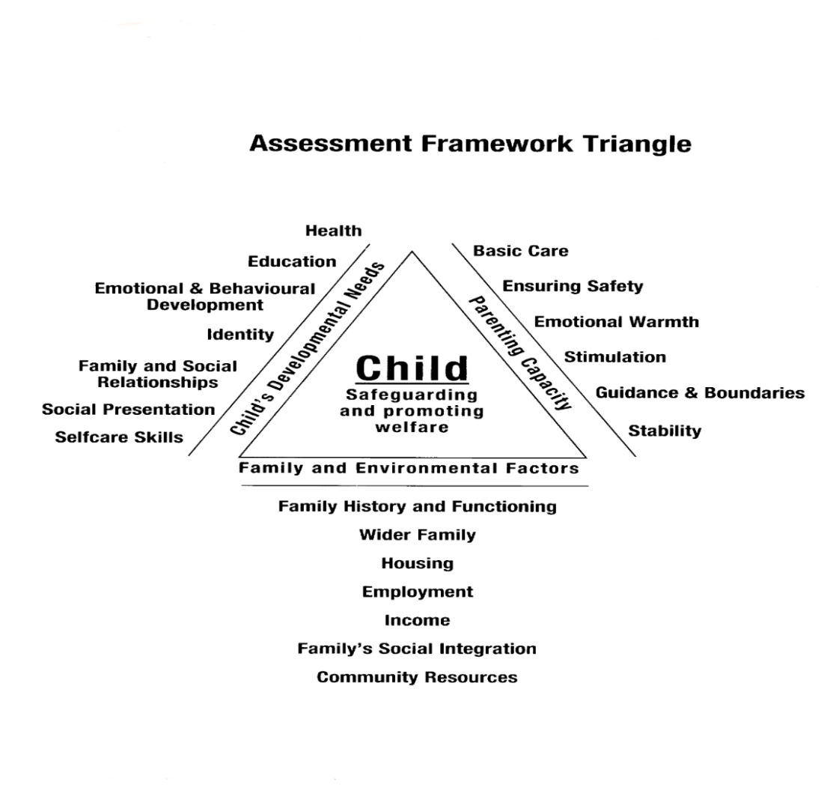

**DEFINITION OF A CHILD IN NEED**

A child in need is defined under the Children Act 1989 as a child who is unlikely to achieve or maintain a reasonable level of health or development, or whose health and development is likely to be significantly or **further impaired**, without the provision of services; or a child who is disabled. A child should be taken to be in need if:

* He/she is unlikely to achieve or maintain, or to have the opportunity of achieving or maintaining, a reasonable standard of health or development without the provision for him/her of services by a local authority
* His/her health or development is likely to be significantly impaired, or further impaired without the provision for him/her of such services
* He/she is disabled. (Section 17(10), Children Act 1989)

**CRITERIA FOR MAKING A CHILD SUBJECT TO A CHILD PROTECTION PLAN**

Every professional in the conference will be asked to give a view on significant harm for each child heard.

The conference should consider the following questions when determining whether the child should be made subject to a child protection plan:

* Has the child suffered significant harm, and is the child at risk of possible, likely or actual suffer significant harm in the future?

If it is a single event that has brought us to ICPC, it is important to recognise that the child has suffered significant harm, but when deciding whether the child should be made subject to a CP plan it is dependent upon the judgement that the child will suffer significant harm again, in the future, whether by another further single incident, or an accumulation of significant events.

The chair should determine which category of abuse or neglect the child has suffered or is likely to suffer.

The chair will consider the views of all agencies and will then determine the final status of the plan. The chair should determine which category of abuse or neglect the child has suffered or is likely to suffer:

* Physical Abuse
* Emotional Abuse
* Sexual Abuse or Exploitation
* Neglect

**CONFIDENTIALITY STATEMENT**

The matters raised in this report are confidential to members of this conference and the agencies that they represent, and should only be shared with others for the purpose of promoting the safeguarding and welfare of the children concerned. All reports provided to Conference will be distributed on the strict understanding that they will be kept confidential and in a secure place.

**INFORMATION SHARING AND DATA PROTECTION**

Should there be a need to share any of the information included in this report with other professionals who are involved with the family but who were not present at conference or for managerial or supervisory purposes this is acceptable.

**EQUAL OPPORTUNITIES STATEMENT**

OSCB are committed to ensuring that current and potential service users are treated with dignity and respect and will not be discriminated against on the grounds of their social circumstances or background, such as gender, race, colour, ethnic origin, religion or belief, disability, gender identity, sexual orientation or age.